journey into academics

*Kuewu Pamela, 22048845, Basic and Applied Sciences, Department of Computer Science*

# Table of contents

Exploring campus culture 4

Program of study 6

Favorite subject 7

History of the premier university 8

Experience in the University of Ghana 9

*Choice of institution* 10

State of accommodation 11

Course in detail 12

# LIST OF FIGURES

Figure 1- personality 5

Figure 2- window 6

Figure 3- myself 7

Figure 4- friend 7

Figure 5- aim 8

Figure 6- studies 9

Figure 7- campus 11

Figure 8- experience 12

Figure 9- institution 13

Figure 10- accommodation 14

Table 1 (COLLEGES, SCHOOLS AND DEPARTMENTS) …………………………………………………….8

**ACKNOWLEDGEMENT**

I would like to express my heartfelt gratitude for your unwavering support towards my academic journey.

You have been my backbone since I began this path of letting in the impartation of knowledge. I can no longer hide my emotions toward your care and kindness for me.

I would also like to thank my hardworking teachers for playing a mentorship role in my life since I began this educational tour.

I sincerely appreciate the believe and trust you have for me and I also promise not to let you down.

**Introduction**

This unique project gives you a walk through my life. Within this document is the whole content of my journey and experiences about my professional life. In this project my academic life would be the main content since that is what brings out the highest demand. This project serves as a window into my story, highlighting important moments, the devastating once and the growth I have gone through along the way till now. This project would also however enlighten you on the brief history of the luxurious University of Ghana, how it came into being and also the personalities that have played crucial roles in its existence. I believe you are more eager by now to dive into this interesting project with me. As we go more deeper into it I have raising hope that you are going to have more fun, sad moments and also learn a lot.

**Biography**

I stand as a disciplined and courageous young lady who is ready to accomplish all aims regardless of any challenge either afore or beyond. I have being through several challenges even at a tender age which has played a great role in my life. My experiences in life has made me come up with the motor “Nothing Scares my mind, spirit and heart”.

I respond to the name Kuewu Pamela, a proud Monday born. I came into being on the 4th of September, 2006, which literally informs you that I am a 17 years old lady. I trace my ancestors to a hospitable town, Vakpo in the volta region of Ghana. Being born and bred in a well-organized family, I grew up, getting to develop the sense of taking up responsibilities at their appropriate times. This nurtured my life and shaped my thought towards the cruel and unfair life I was going to face throughout my journey as a human.

On completing my primary and secondary education which actually took place at two different jurisdictions, katamansu and Vakpo respectively, I decided to further my education at the University of Ghana where I obtained a degree in the Bachelor of Science in Information Technology. My educational journey has put much interest in me to pursue this course, however I am much determined to take up a career from this field of study.

Figure 1- personality

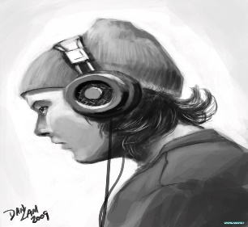Jumping into my life beyond academics, I am a delighted introvert who has higher interest in music. I listen to music in order to maintain my talent which is singing. I love to impart knowledge into the people around me and as well receive more from them. I am not a social person as my personality makes me but then I keep the circle of friends around me into my “basket of flowers”. I enjoy watching foreign movies which keeps me updated with my grammar. This makes me stand out from those around me and it makes me feel unique.

My professional life makes me stand out as a leader who is heartful with care and is aspired to inspire those around her. I make sure I impart positively into the lives of those around me and beyond. I strive to contribute to the betterment of myself, family and my society as well.

As I sail through this academic environs at the University of Ghana, I am excited to immerse myself in the vibrant academic and cultural environment it brings forth. I look forward to having imparting experiences, getting to meet people of my-like and furthering my professional growth.

Chapter 1

# Exploring campus culture

Before I became a full member of this outstanding community, I had a bunch of information and a lot of comments about the University of Ghana. This information accredited both positive and negative once. The positive aspect was about the scholarships being given to well intelligentsia students in this institution whereas the negative aspect talked about the institution being a venue for parties and gathering for all kinds of celebrations.

Figure 2- window

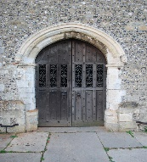I had never being into this institution before my admission here, and so on my first arrival on campus I was so amazed with the structures even though some of it looked like structures from the past especially the windows on the various halls on campus. I realized on thing from its member(students), and that was their dressing code. Most of them were in trousers, snickers and also almost all the ladies were “sweeping the campus with their long -braided hairs”. This made me so mesmerized. The main goal of coming to campus on that day had to be achieved and therefore I had to rouse from my day dreaming into reality and hit the nail on the head. I became a numb person after I had walked miles looking for just one department, and to my surprise almost all the continuing students did not know where the department of computer science was even located. They only suggested that we I go to the information studies department. I guess you already know the feedback after I arrived there. This journey was so hectic but I could not give up so early. So I took myself back to the information center to inquire and the I finally had the right feedback which led me to my current department. On my arrival I got in touch with the levels ahead of me and there I asked for an insight into the program I choose to study.

They provided me with every information I needed to receive, there and then I had to set my belts so tight for the four years journey ahead of me. I had to quickly adjust to the campus culture and also bring the best out of myself. The random allocation of bed information got to me so late that I confusingly chose commonwealth instead of any of the other halls. On my realization to this fact portal had already been closed and I knew I had no other option than to go off campus. I was extremely exhausted after my registration and therefore decided to go home to have the last rest of my life. I was only left with the thought on how of how to gain accommodation since lectures would begin after two days.

I officially arrived here on Monday to have lectures, that was DCIT101, it did not really go as expected though but it was okay. I had no idea of what was going to be lectured and therefore I expected less. Subsequently I was getting used to the fact that my life was to be defined by my own actions, either I would disgrace the course I had chosen or I would allow the course to disgrace me. The lecture that gave me this philosophy was the DCIT 105. Dr Solomon Mensah took as through the course outline, then I realized I made a very huge mistake in the selection of my course in SHS, I made a mistake by running away from E-math to do the less -easier courses. But I believed in myself that I could sail through.

Since the semester began, I have not really had time to engage myself in any extra activity, this is because I am most of the time caught up trying to complete DCIT 103 assignment which is given by Dr Mark Atta Mensah. He stands out so discipline that he keeps us busy from being distracted by all sorts of worldly stuffs.

Figure 3- myself

My personality trait has made it a bit challenging for me to socialize. But I now have a moderate number of people being added to my circle. Their presence in my life has led to a massive change in my understanding of life as a whole. Well I guess you would be wondering who is in the photograph at the left. Her name is Nureat Ahmed-Sey, she is one of the cherishing friends in my circle.

Figure 4- friend

I celebrated my memorable day with her and that was the matriculation day. I made up my mind to ignore the event but she had convinced me enough to avoid missing it. I had a lot of fun and also learnt a lot from that day. I met new personalities and influencing lectures whom I spoke with to get more understanding.

Far from that, my first makeup in life took place on the matriculation day, I could not imagine my looks afterwards. The afterward look was so glamouring and I am on the right side. This photoshoot made me realize the beauty in success if I only remained diligent with my academics.

Chapter 2

## Program of study

Bachelor of Science in Information Technology is the course I study in this premier university. I chose to study this course for a number of factors. In the world of changing and evolving technology, I was able to self-predicted for the next 40 years to come so many courses that are into more reading would have been made unemployed. This is because each and everyday the world comes up with new inventions and more focus is now placed on well-equipped individuals who could make extraordinary thing out of one thing.

This boosted my moral to stand in and conquer my fear in other to live in the present as an I.T personnel. One other major factor that brought me this far is the love I have for my family, who tend to be my source of motivation. I thought of learning a new thing that I could personally use to build up innovations that could make life easier for my family.

For the past months reading the course, I have to realize that the course demanded more and more attention to be able to catchup. The course seems interesting and also confusing at the same time it is so confusing.

The future is always promising with this course as far as I remain consistent and diligent. And this has even made it a source of moving my demeanor in mastering in the course.

Figure 5- aim



Chapter 3

### Favorite subject

Since I began the semester, I have become so conversant and interested in one particular course that I am ready to further into it if the opportunity arises. This course goes by the name Office Productivity Tools, it delves into designing, calculations, and more professional stuff. I really like this course because it is profession neutral, and at every point of mans life it is needed in order to keep relevant information.

I have equally heard a lot of people describing the joy this course has brought them in terms of income and fame. So, I will equally grab the opportunity of venturing into it.

There are this other two courses that keep my attention but seem a bit challenging for me. These courses include computer science and Mathematics for I.T professionals. These courses are also interesting courses I would like to pursue if am able to grasp the concept. They seem interesting and complicated at the same time.

So, basically those are the courses are love the most and they also turn out to be my cores.



Figure 6- studies

Chapter 4

#### History of the premier university

The university of Ghana was founded in the year 1948 and was initially named university college of gold coast in the British colony of Gold coast. It was originally an affiliate college of the London university.  After Ghana gained independence in 1957, the college was renamed the University College of Ghana. It changed its name again to the University of Ghana in 1961, when it gained full university status.

The University of Ghana is situated on the west side of the Accra Legon Hills and northeast of the center of Accra. It has over 60,000 registered students.

The establishment of University Colleges in collaboration with the University of London was one of the recommendations made by the Asquith Commission, which was established in 1943 to look into Higher Education.

A number of distinct Commissions in various locations followed this. The Right Honorable Walter Elliot presided over the West Africa Commission. A majority report by the Elliot Commission proposed the creation of two University Colleges in Ghana and Nigeria, whereas a minority report maintained that only one University College could realistically be established for all of British West Africa. Initially, the British Government acknowledged the Elliot Commission's minority recommendation and determined that a University College should be established for the entirety of British West Africa.

The University of Ghana has about four colleges which include, the college of Humanities, Basic and applied sciences, Health science and the college of education. The college of Basic and Applied Science has about four schools and ten departments, the college of Health Sciences also has four schools and twelve departments, the college of Humanities also has four schools and eleven departments lastly the college of Education has two schools and six departments. Table 0‑1 (COLLEGES, SCHOOLS AND DEPARTMENTS)



Figure 7- campus

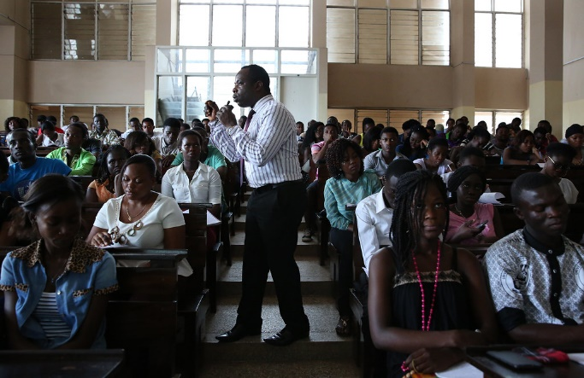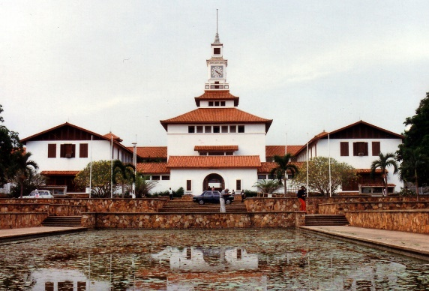

Chapter 5

##### Experience in the University of Ghana

I was overwhelmed as I stepped my foot on the University of Ghana campus. The sheer magnitude of the university, with its labyrinthine corridors and bustling student life, seemed daunting yet exhilarating. It had never crossed my mind that it was going to be a whole- lots of experiences in the aspect of shaping my academics, probably my social life and personal growth.

The heart of the campus pulsed with vitality made me feel the change of environment that I had to do everything possible to adapt as quickly as possible. I had never been to any university before I came to campus so everything seemed new and different to me. But the best thing that ever happened to me was that I had a bid brother who gave ne some vital tips on how to live my life as l long as I stayed on campus.

I am a non-resident and therefore campus real-time experience has not been that frequent. When it comes to the little I have experienced it was hectic. And this was caused by my academics, during the registration and also settling in to become used to the environment.

Since I came, I have really involved myself in any extracurricular activity like clubbing, sports or any student organization. When it comes to my social life, I was able to connect with a circle of friends who are so helpful and more enlighten with puts me to an advantage. I was also able to socialize with few of my roommates who have been so honest and supporting. It has been a life changing experience with the new found friends and colleagues.

Challenges and Growth has been the whole journey of life before I even came to this institution. Nothing scares and seem new to me anymore. But I can say I really learnt from my new circle how to move from been an introvert at the appropriate times to be myself.

Figure 8- experience

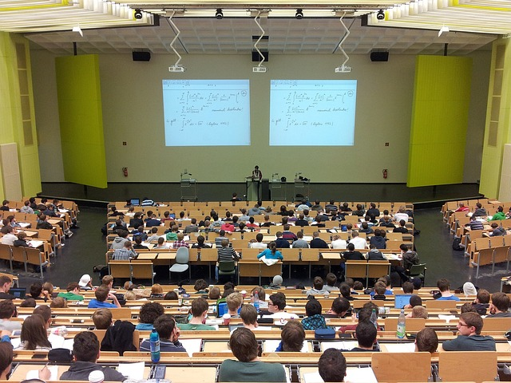

Chapter 6

###### Choice of institution

The selection of the various institutions I decided to pursue my career was a lot and all their qualities almost weighed equally. I used months in the research for the university that was going to suit my choice and also feed me with the knowledge I was expecting to attain and even beyond.

After some acceptable period of time I finally made my decision by coming to study at the university of Ghana. I did not make the wrong decision by choosing the university of Ghana as my first choice of institution. This is because I have being exposed to a wide range opportunities that would become mine after I attain the needed criteria needed to gain it.

It was also written on the university of Ghana website that, well intelligentsia students who do not have the capacity of funding for themselves would be assisted in the form of presentation of scholarship in order to make them comfortable to bring out their capabilities.

This and many more sponsorships gave me the enthusiasm to grab the opportunity of studying in this noble institution. The academic reputation of a university often stands at the forefront of a student’s decision-making process. A university renowned for its high educational standards, distinguished faculty, and research achievements can provide students with a robust platform for academic excellence. The quality of the programs offered is equally crucial. Prospective students seek courses that not only align with their academic interests but also offer comprehensive curricula, modern facilities, and a track record of successful alumni.

The geographical location of a university can significantly influence a student’s choice. Some may prefer an urban setting that offers a vibrant city life and ample career opportunities post-graduation. Others might be drawn to a serene campus nestled in a quieter, more rural area, conducive to focused study and reflection. The lifestyle associated with a university’s location, including climate, cultural offerings, and recreational activities, also plays a part in the decision.

Beyond the tangible factors, the concept of ‘fit’ is perhaps the most subjective yet essential aspect of choosing a university. It’s about finding a place that resonates with one’s personal values, aspirations, and learning style. This intangible feeling of being ‘at home’ on a campus can be the deciding factor for many students. It is often discovered through campus visits, interactions with current students, and introspection about one’s long-term goals.

Hopefully these are some reasons I chose to study here in the University of Ghana.

Figure 9- institution

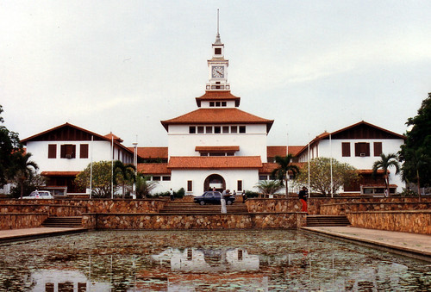

Chapter 7

State of accommodation

Living on campus was my main goal. But after the random allocation I was unfortunate and therefor I had to go off campus. As I stated afore I had the hostel on the day of my first lectures. I would have risked my life if l had not gotten one. This is because from my home to campus was quite far and the mean of getting back, that is the medium of transport was not available at my side at certain periods of time.

One advantage of living off-campus is that it gives you a level of independency since you be the sole proprietor of all your activities. Living off-campus often meant I had more space to breathe. I appreciated having my own enclosed environment and even if not, I should have vivid number of people sharing that space with me.

However, the off-campus experience is not without its hurdles. This follows up with the daily commute which was and is still is a significant time commitment, especially for me who relay on public transportation. Time management has become a crucial skill, as I must adjust and also learn how to balance my travel time with academic responsibilities and social life as well. The isolation from spontaneous campus events can also be a downside, requiring more efforts to stay connected with the university life.

Another consideration for non-resident students is the financial aspect. While off-campus housing can be more cost-effective, it also comes with additional responsibilities such as rent, utilities, and groceries. Budgeting becomes a part of daily life, as students learn to navigate the financial realities of independent living.

Finally, there's a blend of freedom, personal space, and true world experience when you live as an outsider on campus. It's teaching valuable life lessons about independence, financial management, and self- reliance. It is a challenge, but also an opportunity for growth as it involves commuting and the possibility of feeling disconnected from campus culture. Living away from campus may be an enriching complement to the academic pursuit of those choosing this path.

Figure 10- accommodation

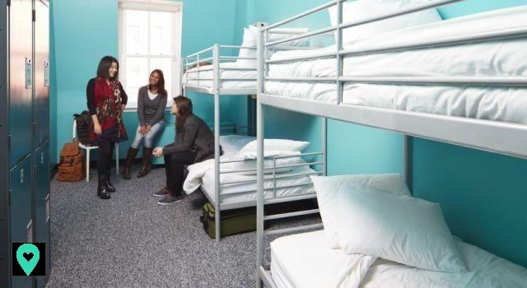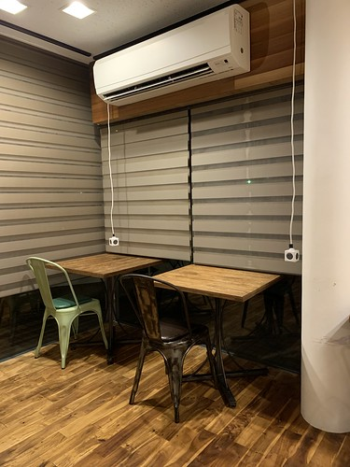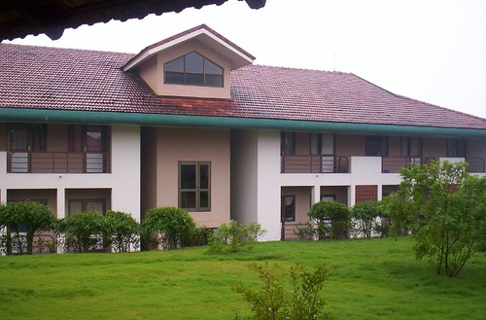

Chapter 8

Course in detail

Office productivity tool as a course on its own is a very interesting course. My conclusion on this, assumptions come out from the experiences I have had so far. For the past months studying the course, I have come to the realization that the course enables individuals to explore more into the world of arts and design. It improves on the structure of the function of the brain since it allows individuals to think wide and create extraordinary designs with their minds.

The instructions needed in completing a project is vividly stated in most of our assignment which makes learning and completion of assignment so easy and interesting. Every point or method is clearly stated and also the location each feature on the program in use.

With the aspect of assessment, we have 70% of the overall score dependent on our quizzes, capstone projects and the various assignments been given. The remaining percentage is on our examinations. This has made some of us so focused on getting the best in the various categories that amount the highest percentage value.

The instructor who goes by the name Mr. Mark Atta Mensah, is termed by all including myself as a well -disciplined man who holds his duty in high esteem. This makes him unique from all other instructors. He makes sure he keeps us so busy that we cannot be caught up tempted by the enemy. He is also God fearing and also spends much of his time guiding us on how to live our lives on campus as students and neighbors.

I as a student of the Office Productivity Tools course intend to gain insight into the to be able to apply it in the most aspect of my life. This course has actually improved upon my logic which has opened my mind and the scope of my thoughts. It has also given me diverse ways to express my thoughts, this could be through designing and also creating contents on my own.

DCIT 103 as compared to other courses am reading seem to be the easiest amongst them. It does not really involve a lot of reading but rather consistent practicing.